A Project Report

On

Mems Based Hand Gesture Robot Control

Submitted in partial fulfilment of the requirements for the award of the degree of

BACHELOR OF TECHNOLOGY

In

COMPUTER SCIENCE AND ENGINEERING

By

Shaik Karishma 22NN1A05A9

Chiranji Geetha 22NN1A0574

Vutla Nandhini 22NN1A05B9

Md Mubasheera 22NN1A0596

Under the Esteemed Guidance of

Y. Swathi

Assistant Professor



DEPARTMENT OF COMPUTER SCIENCE AND ENGINEERING

VIGNAN’S NIRULA INSTITUTE OF TECHNOLOGY AND SCIENCE FOR

WOMEN

PEDAPALAKALURU, GUNTUR-522005

(Approved by AICTE, NEW DELHI and Affiliated to JNTUK, Kakinada.)

2020-2024

VIGNAN’S NIRULA INSTITUE OF TECHNOLOGY AND SCIENCE FOR WOMEN

(Approved by AICTE, NEW DELHI and Affiliated to JNTUK, Kakinada)

PEDAPALAKALURU, GUNTUR-522005

DEPARTMENT OF COMPUTER SCIENCE AND ENGINEERING


CERTIFICATE

This is to certify that the project entitled “Mems Based Hand Gesture Robot Control”, is a bonafide work of Shaik Karishma(22NN1A05A9) submitted to the faculty of Computer Science And Engineering, in the partial fulfilment of the requirements for the award of degree of BACHELOR OF TECHNOLOGY in COMPUTER SCIENCE AND ENGINEERING from VIGNAN’S NIRULA INSTITUTE OF TECHNOLOGY AND SCIENCE FOR WOMEN, GUNTUR.

Project Guide Head of the Department

Y. Swathi Dr. V Lakshman Narayana

Assistant Professor

EXTERNAL EXAMINER

DECLARATION

We hereby declare that the work described in this project work, entitled “Mems based Hand Gesture Robot Control” which is submitted by us in partial fulfilment for the award of Bachelor of Technology in the Department of Computer Science and Engineering to the Vignan’s Nirula Institute of Technology and Science for women, affiliated to Jawaharlal Nehru Technological University Kakinada, Andhra Pradesh, is the result of work done by us under the guidance of Y. Swathi, Assistant Professor.
The work is original and has not been submitted for any Degree/ Diploma of this or any other university.

Shaik Karishma 22NN1A05A9

Chiranji Geetha 22NN1A0574

Vutla Nandhini 22NN1A05B9

Md Mubasheera 22NN1A0596

ACKNOWLEDGEMENT

We express our heartfelt gratitude to our beloved principal Dr. P. Radhika for giving a chance to study in our esteemed institution and providing us all the requires resources
We Would like to thank Dr V Lakshman Narayana, Associate Professor, Head of the Department of Computer Science and Engineering, for his extended and continuous support valuable guidance and timely advices in the completion of this project thesis
We wish to express our profound sense of sincere gratitude to our Project Guide Y. Swathi, Assistant Professor, Department of Computer Science and Engineering , without whose help, guidance and motivation this project thesis could not have been completed the project successfully.
We also thank all the faculty of the Department of Computer Science and Engineerjng, without whose help, guidance and motivation this project thesis could not have been completed the project successfully.
We also thank all the faculty of the Department of Computer Science and Engineering for their help guidance of numerous occasions, which has given us the cogency to build-up adamant aspiration over the completion of our project thesis.
Finally, we thank one and all who directly or indirectly helped us to complete our project thesis successfully
PROJECT ASSOCIATES

Shaik Karishma 22NN1A05A9

Chiranji Geetha 22NN1A0574

Vutla Nandhini 22NN1A05B9

Md Mubasheera 22NN1A0596

MEMS BASED HAND GESTURE ROBOT CONTROL

INDEX
CHAPTER-1

INTRODUCTION 10

Introduction to Project 10

Introduction to Embedded System 11

1.3 Introduction to IOT 11

1.4 Need of IoT 13

CHAPTER-2
2.1Introduction 14
2.2 Mems Technology 14
2.3 Hand Gesture Recognition 14
2.4 Accelerometers for Gesture Recognition 14
2.5 Microcontrollers in Gesture Control Systems 14
2.6 Integration of ADXL345 with ESP8266 14
CHAPTER-3
3.1 Introduction 15
3.2 Objectives 16

3.3 Block Diagram 17

3.4 Tools required 18

CHAPTER-4

4.1 Node MCU ESP8266 20

4.1.1 About the Node MCU ESP8266 Pinout 21

4.1.2 Node MCU ESP8266 Pinout 22

4.2.1: Adxl345Description 23

4.2.2 Working Principle 24

CHAPTER-5

SOFTWARE IMPLEMENTATION 25

5.1 Arduino IDE 25

5.1.1 Introduction to Arduino IDE 25

5.1.2 How to Download Arduino IDE 26

5.1.3 Libraries 30

5.1.4 Making Pins Input or Output 31

5.1.5 How to Select the Board 31

5.1.6 Uploading 33

CHAPTER-6

RESULT 35

CONCLUSION 36
FUTURE SCOPE 37

SOURCE CODE 42
REFERENCES 43

ABSTRACT
A robot is a system that deals with construction, design, and operation. This system is related to robot and their design, manufacture, and application. Robotics is currently focused on developing systems that modularity, flexibility, redundancy, fault tolerance and some other researches are on completely automating a manufacturing process or a task, by providing sensor based to the robot arm. Recently developing industry and manpower are critical constraints for the completion of a task. To save human efforts automation plays an important role in the system. This system is used for regular and frequently carried work. One of the major and most commonly performed works is picking and placing jobs from source to destination. In the earlier systems, the motion of the human hand is sensed by the robot through sensors and follows the same. As the human travels their hand, the accelerometer also start moving according motion of the hand sensor displaces and their sensors senses object or parameter according to motion of hand.

CHAPTER-1
INTRODUCTION
1.1 Introduction to Project

In recent years, the development of MEMS (Micro-Electro-Mechanical Systems) technology has significantly advanced the field of robotics, particularly in the area of human-machine interaction. One of the most promising applications of MEMS is in the creation of hand gesture-controlled robots. These robots use MEMS sensors to interpret the motions of a human hand and convert these motions into commands that control the robot's movements. This technology has broad implications, ranging from assistive devices for individuals with disabilities to innovative control interfaces for various robotic systems.
1.2 Mems Technology and Hand Gesture Recognition
MEMS technology integrates mechanical elements, sensors, actuators, and electronics on a common silicon substrate through microfabrication technology. These sensors are highly sensitive to changes in physical parameters such as acceleration, tilt, and orientation, making them ideal for detecting hand gestures. MEMS accelerometers and gyroscopes are commonly used to capture the dynamic and static movements of the hand.
1.3 Implementation in Robotics
In a MEMS-based hand gesture-controlled robot, the MEMS sensors are typically mounted on a glove or directly on the hand. As the user performs various gestures, the sensors collect data on the hand's movement and orientation. This data is then processed by a microcontroller, such as the ESP8266, which interprets the gestures and translates them intcommands that drive the robot's motors. The ESP8266 is a popular choice for such projects due to its built-in Wi-Fi capabilities, allowing for wireless communication between the hand module and the robot. The processed data can be sent wirelessly to the robot, enabling real-time control and flexibility in robot operation.
Characteristics of Embedded System.
1.High Sensitivity and Precision: Captures fine details of hand movements with accuracy
2.Real_Time Processing: Providing near_instantaneous response to gestures
3.Wireless Communication: Enables flexible control through Wi-Fi capabilities
4.User-Friendly Interface: Intuitive and comfortable glove and hand mounted sensor.
5.Versatility and Adaptability: Customizable gestures for various applications.
6.Compact and Lightweight Design: Miniaturized and portable control unit.
1.4 Introduction to IOT
INTERNET OF THINGS (IoT) is the networking of physical objects that contain electronics embedded within their architecture in order to communicate Interaction amongst each other or with respect to the external environment. In the upcoming years, IoT-based technology will offer advanced levels of services and practically away people lead their daily lives. Advancements in medicine, power, gene therapy agriculture, smart cities, and smart homes are just a very few of the categorical example where IoT is strongly established. IoT is network of interconnected computing devices which are embedded in everyday objects, enabling them to send and receive data. With more than 7 billion connected IOT devices today, experts are expecting this number to grow to 10 billion by 2020 and 22 billion by 2025. Oracle has a network of device partners.
The most important features of IoT on which it works are connectivity, integrating, active engagement, and many more. Connectivity refers to establish a proper connection between all the things of IoT platform it may be server or cloud. After connecting the IoT devices, it needs a highspeed messaging between the devices and cloud to enable reliable, secure and bi-directional communication. IoT makes things smart and enhances life through the use of data. For example, if we have a coffee machine whose beans have going to end, then the coffee machine it orders the coffee beans of your choice from the retailer. The most important features of IoT on which it works are connectivity, analysing, integrating, active engagement, and many more. Some of them are listed below:
Connectivity: Connectivity refers to establish a proper connection between all the things of IoT platform it may be server or cloud. After connecting the IoT devices, it needs a highspeed messaging between the devices and cloud to enable reliable secure and bi-directional communication.
Analysing: After connecting all the relevant things, it comes to real-time analysing the data collected and use them to build effective business intelligence. If we have a good insight into data gathered from all these things, then we call our system has a smart system.
Integrating: IoT integrating the various models to improve the user experience as well.
Artificial Intelligence: IoT makes things smart and enhances life through the use of data. For example, if we have a coffee machine whose beans have going to end, then the coffee machine it orders the coffee beans of your choice from the retailer.
Sensing: The sensor devices used in IoT technologies detect and measure any change in the environment and report on their status. IoT technology brings passive networks to active networks. Without sensors, there could not hold an effective or true Iot environment.
Active Engagement: IoT makes the connected technology, product, or services to active engagement between each other.
Endpoint Management: It is important to be the endpoint management of all the IoT system otherwise, it makes the complete failure of the system. For example, if a coffee machine itself order the coffee beans when it goes to end but what happens when it orders the beans from a retailer and we are not present at home for a few days, it leads to the failure of the IoT system.
1.5 Need of IoT
The Internet of Things (IoT) stands as a transformative force, reshaping our interactions with the world and revolutionizing diverse aspects of our daily lives. At its core, IoT thrives on connectivity, fostering seamless communication between devices and promoting interoperability. Through automation, IoT enhances efficiency by enabling devices to operate autonomously based on predefined conditions or real-time data, reducing the need for constant human intervention. In the realm of smart cities, IoT contributes to urban development by introducing intelligent transportation systems, energy management, and sustainable practices, thereby enhancing overall quality of life. Health care benefits from IoT through wearables and remote monitoring tools, offering personalized insights and timely interventions. Industries leverage Industrial IoT (IIoT) to optimize manufacturing processes, monitor equipment health, and implement predictive maintenance strategies, leading to increased productivity and cost savings. From smart homes with connected appliances to environmental monitoring and supply chain optimization, IoT's impact is far-reaching, creating a more connected, efficient, and intelligent world across various domain

CHAPTER 2
LITERATURE SURVEY
2.1 Introduction:
Introduction to MEMS technology and its applications in hand gesture recognition.
Significance of hand gesture control systems in robotics and interactive systems
2.2 Mems Technology:
Micro-Electro-Mechanical Systems (MEMS) combine electrical and mechanical components at a microscopic scale, sensors (accelerometers, gyroscopes, magnetometers) Actuators (micromotors, microvalves).
2.3 Hand Gesture Recognition
wearable sensor -Devices like accelerometers and gyroscopes mounted on gloves or directly on the hand. Computer vision- Camera-based systems for recognizing hand gestures. Less affected by lighting conditions and occlusions. Provide continuous data on hand movements. Accelerometers-
2.4 Accelerometers for Gesture Recognition:
Functionality-Measure acceleration forces along three axes (X, Y, Z), Commonly Used ADXL345: A 3-axis accelerometer with I2C and SPI communication interfaces, widely used due to its accuracy and ease of interfacing with microcontrollers.
2.5 Microcontrollers in Gesture Control Systems: Popular Microcontroller ESP8266: A low-cost Wi-Fi microchip with full TCP/IP stack and microcontroller capability. Arduino- A microcontroller platform commonly used for prototyping, esp8266-Built-in Wi-Fi for wireless communication. Adequate processing power for real-time gesture recognition.
2.6 Integration of ADXL345 with ESP8266
Wiring and Communication-Utilizing I2C or SPI interfaces for data transfer between ADXL345 and ESP8266.Data Processing-Real-time acquisition and processing of acceleration data to recognize hand gestures.

II.LITERATURE REVIEW
1.MEMS-Based Hand Gesture Recognition System for Robot Control
This explores the use of MEMS accelerometers for detecting hand gestures and controlling robotic systems. The study highlights the accuracy and responsiveness of MEMS sensors in capturing hand movements.

2. Implementation of a Wearable Gesture Control Interface Using ESP8266 and ADXL345
It discusses the integration of the ADXL345 accelerometer with the ESP8266 microcontroller to create a wearable gesture control interface. It emphasizes the ease of use and low cost of this setup for real-time applications.

3. Wireless Gesture-Controlled Robot Using MEMS Accelerometer and Wi-Fi Module
This presents a wireless robot control system utilizing a MEMS accelerometer and a Wi-Fi-enabled microcontroller. The system's performance in terms of response time and accuracy is evaluated.

CHAPTER-3
DESIGNED SYSTEM
3.1 Introduction
The MEMS-based hand gesture robot control system is a project aimed at utilizing the ESP8266 microcontroller and ADXL345 accelerometer to detect hand gestures and control a robotic hand. The system interprets gestures from the user and translates them into corresponding movements of the robotic hand, enhancing human-machine interaction in a user-friendly and intuitive manner.
3.2 Objectives
The primary objective of this project is to design and implement a hand gesture-controlled robotic system. This system aims to:
- Enhance Accessibility: Develop a system that can be easily used by people with limited mobility or dexterity, providing an alternative to traditional control methods.
- Increase Precision: Achieve high accuracy in gesture recognition to ensure precise control of the robotic hand movements.
- Improve Responsiveness: Ensure that the system has low latency, providing real-time feedback and control to the user.
- Scalability: Design the system in a modular way so it can be easily expanded to control additional robotic components or more complex robots.
- User-Friendly Interface: Create a simple and intuitive interface for users to calibrate and control the robotic hand without needing advanced technical knowledge.
- Integration with IoT: Enable the system to connect to the Internet of Things (IoT) for remote monitoring and control.
- Energy Efficiency: Optimize the system for low power consumption to extend the operational time of battery-powered setups.
- Robustness: Ensure the system is robust and reliable under different environmental conditions and varying user inputs.
- Customization: Allow for customizable gesture mappings, enabling users to define their own gestures for specific robotic hand movements.
- Educational Value: Serve as an educational tool for learning about MEMS technology, microcontrollers, and robotics.
- Cost-Efficiency: Maintain a cost-effective design without compromising performance, making the technology accessible to hobbyists and educators.
- Safety: Implement safety features to prevent accidental or unintended movements of the robotic hand, ensuring user safety.
- Multi-Platform Compatibility: Ensure the system is compatible with various operating systems and devices for greater flexibility.
- Data Logging and Analysis: Include features for logging gesture data and analyzing performance to improve system accuracy and functionality over time.
3.3 Block Diagram

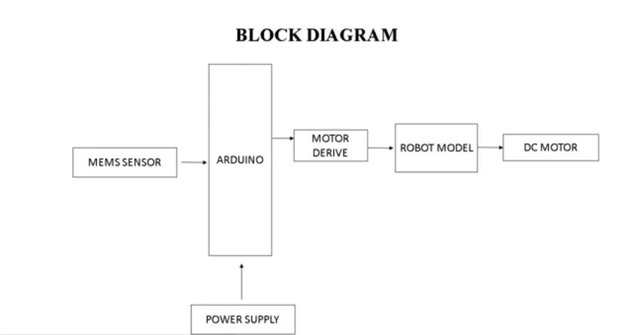

Fig 1.1 Block diagram

3.4 Tools required

Hardware Components
- ADXL345 Accelerometer: A MEMS sensor that detects hand gestures by measuring acceleration in three axes (X, Y, Z).
- ESP8266 Wi-Fi Module: A microcontroller with built-in Wi-Fi, used for wireless communication and control of the robot.
- L298N Motor Driver: A dual H-bridge motor driver module, which controls the direction and speed of the robot's motors.
- Motors and Wheels: To drive the robot based on hand gestures.
- Power Supply: Typically batteries to power the components.
- Chassis: The framework of the robot.

Software Components
- Arduino IDE: For writing and uploading code to the ESP8266.
- ESP8266 Libraries: Required libraries for Wi-Fi and motor control functionalities.
- ADXL345 Libraries: To interface with the accelerometer and process sensor data.

Techniques Used
- Gesture Recognition: Using the ADXL345 to detect specific movements and translate them into commands.
- Communication: ESP8266 handles data transmission and reception over Wi-Fi, enabling remote control of the robot.
- Motor Control: The L298N module receives signals from the ESP8266 and drives the motors accordingly.

Working of Components
- ADXL345 Accelerometer: Detects the tilt and motion of the hand, converting it into digital signals.
- ESP8266 Module: Receives data from the ADXL345, processes the gestures, and sends appropriate commands to the L298N.
- L298N Motor Driver: Executes the received commands to control the motors, adjusting speed and direction to move the robot.
- VCC (ADXL345) to 3.3V (ESP8266)
- GND (ADXL345) to GND (ESP8266)
- SDA (ADXL345) to D2 (ESP8266 GPIO4)
- SCL (ADXL345) to D1 (ESP8266 GPIO5)
- N1 (L298N) to D5 (ESP8266 GPIO14)
- IN2 (L298N) to D6 (ESP8266 GPIO12)
- IN3 (L298N) to D7 (ESP8266 GPIO13)
- IN4 (L298N) to D8 (ESP8266 GPIO15)
- ENA (L298N) to 5V (PWM control, can be connected to PWM pin on ESP8266 if speed control is needed)
- ENB (L298N) to 5V (PWM control, can be connected to PWM pin on ESP8266 if speed control is needed)
- VCC (L298N) to external power supply (e.g., 12V battery)
- GND (L298N) to GND (ESP8266 and battery)

Advantages
- Control: The use of ESP8266 allows for wireless operation, making the system more flexible and easier to use.
- Real-time Gesture Response: The system can quickly interpret and act on hand gestures, providing smooth control over the robot.
- Compact and Efficient: MEMS sensors like ADXL345 are small and power-efficient, making the overall system lightweight and portable.
- Scalability: The system can be easily scaled to include additional sensors or functionalities, such as more complex gestures or additional control mechanisms.
- Cost-Effective: Using components like the ADXL345 and ESP8266 provides a cost-effective solution for advanced robotic control.
- Open-Source Libraries: Availability of numerous open-source libraries for these components facilitates easier development and integration.

CHAPTER-4

HARDWARE IMPLEMENTATION

4.1 Node MCU ESP8266

Description
Node MCU ESP8266 Description Node MCU is an open-source firmware for which open- source prototyping board designs are available. The name “Node MCU” combines “node” and

Fig 4.1: Node MCU

“MCU” (micro-controller unit). The term “Node MCU” strictly speaking refers to the firmware rather than the associated development kits. Both the firmware and prototyping board designs are open source. Node MCU ESP8266 and Node MCU ESP32 are becoming very popular and are almost used in more than 50%
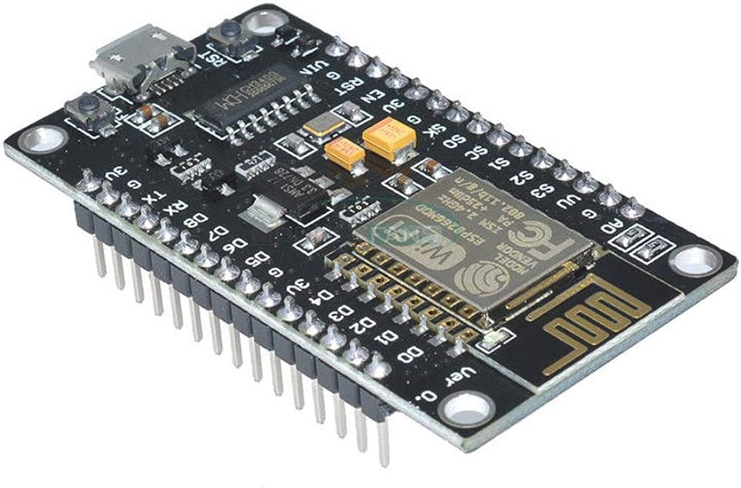
The firmware uses the Lua scripting language. The firmware is based on the eLua project and built on the Espressif Non-OS SDK for ESP8266. It uses many open-source projects, such as luacjson and SPIFFS. Due to resource constraints, users need to select the modules relevant for their project and build a firmware tailored to their needs. Support for the 32-bit ESP32 has also been implemented. The prototyping hardware typically used is a circuit board functioning as a dual in-line package (DIP) which integrates a USB controller with a smaller surface-mounted board containing the MCU and antenna. The choice of the DIP format allows for easy prototyping on breadboards. The design was initially was based on the ESP-12 module of the ESP8266, which is a Wi- Fi SoC integrated with a Tensilica Xtensa LX106 core, widely used in IoT applications.

About the Node MCU ESP8266 Pinout:
Node MCU ESP8266 Wi-Fi Module is an open-source Lua based firmware and development board specially targeted for IoT based applications. It includes firmware that runs on the ESP8266 Wi-Fi SoC from Espressif Systems, and hardware which is based on the ESP-12 module.
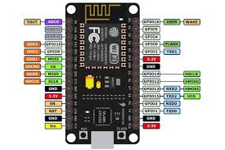

Fig 4.2 Pin Diagram of Node MCU
    - Node MCU ESP8266 Features:
Microcontroller: Tensilica 32-bit RISC CPU
Xtensa LX106 Operating Voltage: 3.3V
Input Voltage: 7-12V
Digital I/O Pins
(DIO): 16 Analog
Input Pins (ADC):
1 UARTs: 1
SPIs: 1
I2Cs: 1
Flash
Memory: 4 MB
SRAM: 64 KB
Clock Speed: 80 MHz
USB-TTL based on CP2102 is included onboard, Enabling Plug n
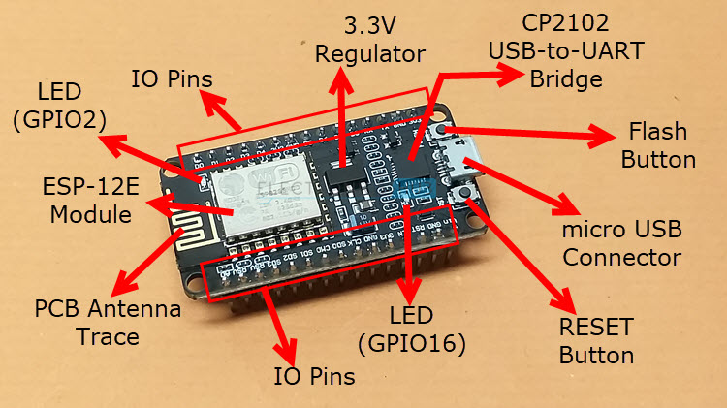
Play PCB Antenna Small Sized module to fit smartly inside your

Fig 4.3: Layout of the Node MCU

4.1.2 Node MCU ESP8266 Pinout:
For practical purposes ESP8266 Node MCU V2 and V3 boards present identical pinouts. While working on the Node MCU based projects we are interested in the following pins.
Power pins (3.3V)
24 Ground pins(GND).
Analog pins(A0).
Digital pins (D0 – D8, SD2, SD3, RX, and TX – GPIO XX)
Most ESP8266 Node MCU boards have one input voltage pin (Vin), three power pins (3.3v), four ground pins (GND), one analog pin (A0), and several digital pins (GPIO XX).

Pin Code Arduino alias
A0 A0 A0
D0 GPIO 16 16
D1 GPIO 5 5
D2 GPIO 4 4
D3 GPIO 0 0
D4 GPIO 2 2
D5 GPIO 14 14
D6 GPIO 12 12
D7 GPIO 13 13
D8 GPIO 15 15SD2 GPIO 9 9
SD3 GPIO 10 10
RX GPIO 3 3
TX GPIO 1 1

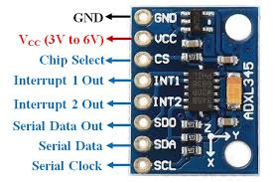
4.2 ADXL345

4.2.1: Description
The ADXL345 is a low-power, 3-axis micro-electromechanical system(MEMS) accelerometer module with both Inter-Integrated circuit (I2C) interface and serial peripheral interface (SPI). The sensor comprises of a micro-scale machined structure on a silicon wafer. The structure is suspended by polysilicon springs which enable it to shift easily toward any path smoothly when subject to increasing speed in the X, Y as well as Z axis. The displacement causes a variation in value of capacitance between the fixed plates and the movable plates (which move due to being attached to the suspended structure). This variation in capacitance along every axis is converted in order to yield an output voltage corresponding to the acceleration along respective axes [4]. The ADXL345 Breakout has an I2C address of 0x53. It can share the I2C bus with other I2C gadgets as long as every gadget has a unique address. Mostly, only 4 connections are required for I2C communication: Serial Data (SDA), Serial Clock (SCL), Voltage Common Collector (VCC) and Ground (GND)

4.2.2 Working Principle
• The ADXL345 measures acceleration in three axes (X, Y, Z) to detect hand movements.
• It uses capacitive sensing technology to detect changes in motion and orientation.
• Tiny internal structures move in response to hand gestures, causing changes in capacitance.
• The changes in capacitance are converted into electrical signals.
• An analog-to-digital converter (ADC) within the ADXL345 digitizes these signals into digital output.
• The digital acceleration data is read via the sensor's I2C interface by the ESP8266 microcontroller.
• The ESP8266 processes the acceleration data to interpret specific hand gestures.
• The ESP8266 translates these gestures into commands for controlling the robot's movements.
• Based on the interpreted gestures, the ESP8266 sends control signals to the L298N motor driver.
• The L298N motor driver adjusts the speed and direction of the robot's motors according to the received commands.
• The ADXL345 continuously updates the output registers with the latest acceleration data for real-time gesture recognition.
• The system ensures responsive and accurate control of the robot based on hand gestures.

CHAPTER-5

SOFTWARE IMPLEMENTATION

5.1 Arduino IDE

5.1.1 Introduction to Ardunio IDE
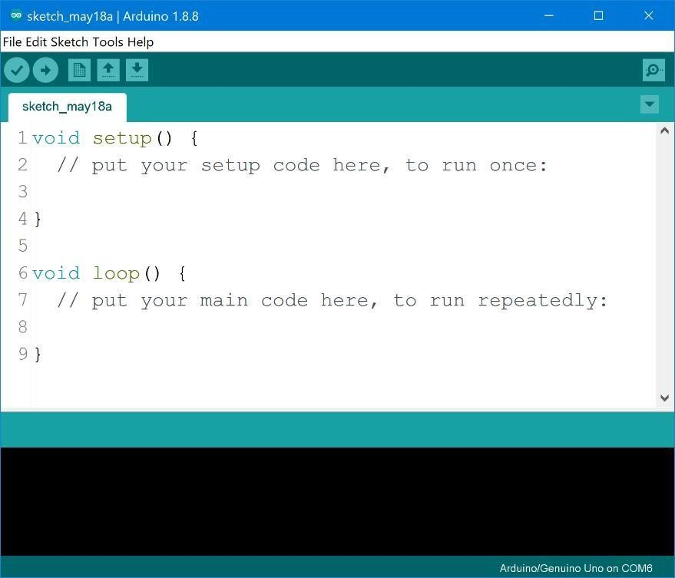
IDE stands for Integrated Development Environment - An official software introduced by Arduino. cc that is mainly used for writing, compiling, and uploading the code in almost all Arduino modules/boards. Arduino IDE is open-source software and is easily available to download & install from Arduino Official Site. In this post, I'll take you through the brief Introduction to the Software, how you can install it, and make it ready for your required Arduino module. Let's dive in and get down to the nitty-gritty of this Software
.

Fig 5.1: Arduino IDE Editor page
Arduino IDE is an open-source software, designed by Arduino.cc and mainly used for writing, compiling & uploading code to almost all Arduino Modules. 28 It is an official Arduino software, making code compilation too easy that even a common person with no prior technical knowledge can get their feet wet with the learning process. It is available for all operating systems i.e., MAC, Windows, Linux and runs on the Java Platform that comes with inbuilt functions and commands that play a vital role in debugging, editing and compiling the code. A range of Arduino modules available including Arduino Uno, Arduino Mega, Arduino Leonardo, Arduino Micro and many more. Each of them contains a microcontroller on the board that is actually programmed and accepts the information in the form of code. The main code, also known as a sketch, created on the IDE platform will ultimately generate a Hex File which is then transferred and uploaded in the controller on the board. The IDE environment mainly contains two basic parts: Editor and Compiler where former is used for writing the required code and later is used for compiling and uploading the code into the given Arduino Module. This environment supports both C and C++ languages.

5.1.2 How to Download Arduino IDE
You can download the Software from Arduino main website. As I said earlier, the software is available for common operating systems like Linux, Windows, and MAX, so make sure you are downloading the correct software version that is easily compatible with your operating system. 8.1 or Windows 10, as the app version is not compatible with Windows 7 or older version of this operating system. You can download the latest version of Arduino IDE for Windows (Non admin standalone version), by clicking below button:

Arduino IDE Download
The IDE environment is mainly distributed into three sections.
1. Menu Bar
2. Text Editor
3. OutputPane
As you download and open the IDE software, it will appear like an image below:
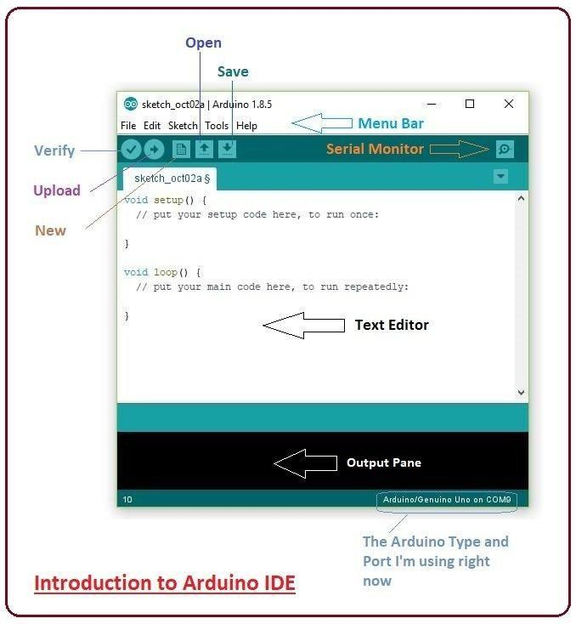

Fig 5.2: Introduction to Arduino IDE
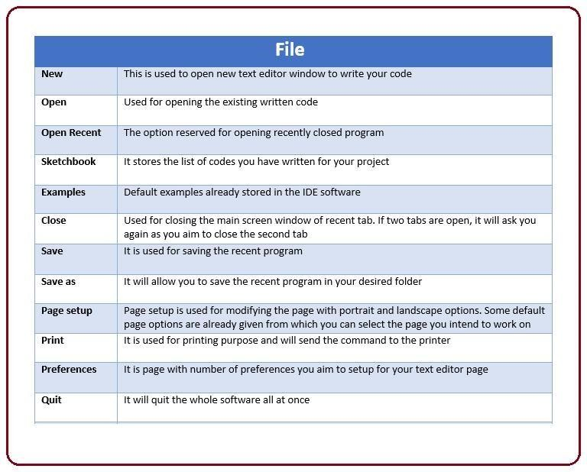
The bar appearing on top is called Menu Bar that comes with five different options as File - You can open a new window for writing the code or open an existing one. The following table shows number of further subdivisions the file option is categorized into:

Fig 5.3: File subdivisions in Arduino IDE
As you go to the preference section and check the compilation section, the Output Pane will show the code compilation as you click the upload button.

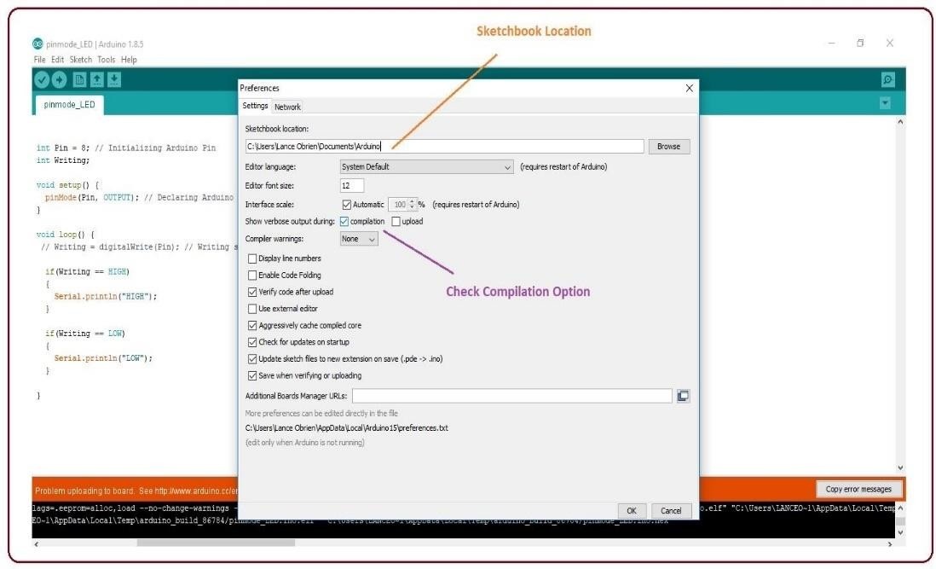

Fig 5.4: Selection of compilation
And at the end of the compilation, it will show you the hex file it has generated for the recent sketch that will send to the Arduino Board for the specific task you aim achieve.
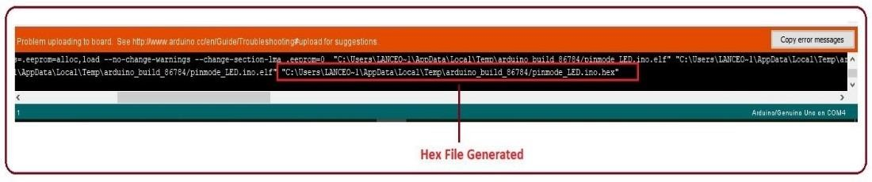

Fig 5.5: Hex file generation
Sketch - For compiling and programming
• Tools - Mainly used for testing projects. The Programmer section in this panel is used for burning a boot loader to the new microcontroller.
• Help - In case you are feeling Edit - Used for copying and pasting the code with further modification for font
• sceptical about software, complete help is available from getting started to troubleshooting.
• The Six Buttons appearing under the Menu tab are connected with the -nning program as follows.

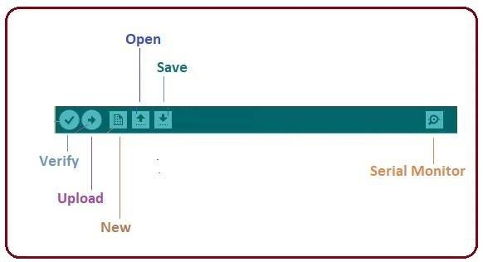

Fig 5.6: Serial monitor
• The check mark appearing in the circular button is used to verify the code. Click this once you have written your code.
• The arrow key will upload and transfer the required code to the Arduino board.
• The dotted paper is used for creating a new file. • The upward arrow is reserved for opening an existing Arduino project.
• The downward arrow is used to save the current running code.
• The button appearing on the top right corner is a Serial Monitor - A separate pop-up window that acts as an independent terminal and plays a vital role in sending and receiving the Serial Data. You can also go to the Tools panel and select Serial Monitor, or pressing Ctrl+Shift+M all at once will open it instantly. The Serial Monitor will actually help to debug the written Sketches where you can get a hold of how your program is operating. Your Arduino Module should be connected to your computer by USB cable in order to activate the Serial Monitor.
• You need to select the baud rate of the Arduino Board you are using right now. For my Arduino Uno Baud Rate is 9600, Monitor, the output will show as the image below.
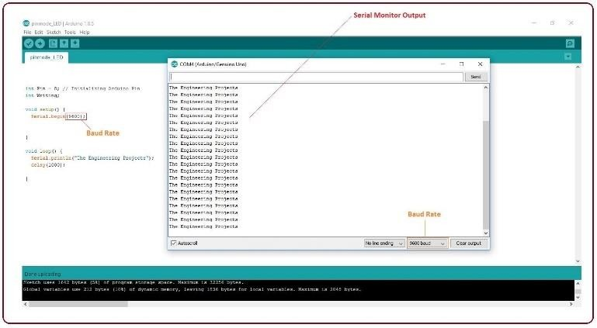

Fig 5.7: output of the serial monitor
The main screen below the Menu bard is known as a simple text editor used for writing the required code.
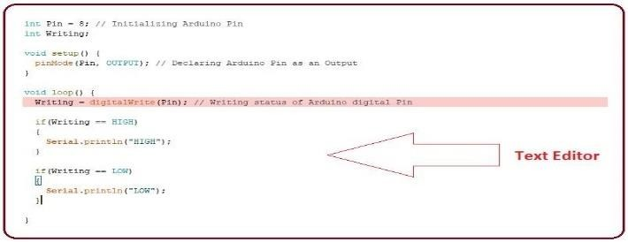

Fig 5.8: Text editor
Output Pane that mainly highlights the compilation status of the running code: the memory used by the code, and errors that occurred in the program. You need to fix the bottom of the main screen is described as those errors before you intend to upload the hex file into your Arduino Module.
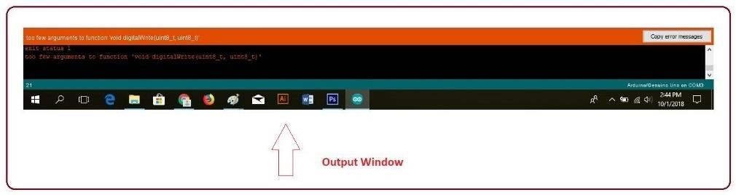

Fig 5.9: output window
More or less, Arduino C language works similar to the regular C language used for any embedded system microcontroller, however, there are some dedicated libraries used for calling and executing specific functions on the board.

5.1.3 Libraries
• Libraries are very useful for adding extra functionality into the Arduino Module.
• There is a list of libraries you can check by clicking the Sketch button in the menu bar and going to Include Library.
• As you click the Include Library and Add the respective library it will be on the top of the sketch with a #include sign.

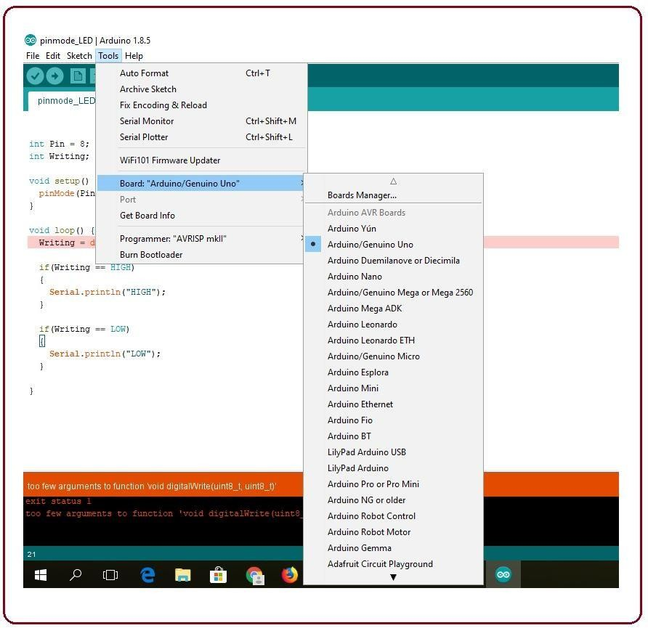

Fig 5.10: Selection of tools

5.1.4 Making Pins Input or Output.
The digitalRead and digitalWrite commands are used for addressing and making the Arduino pins as an input and output respectively. These commands are text sensitive i.e., you need to write them down the exact way they are given like digitalWrite starting 34 with small "d" and write with capital "W". Writing it down with DigitalWrite or digitalWrite won't be calling or addressing any function.

5.1.5 How to Select the Board
• In order to upload the sketch, you need to select the relevant board you are using and the ports for that operating system.
• As you click the Tools on the menu, it will open like the figure below:



Fig 5.11: Selection of board manager
• Just go to the "Board" section and select the board you aim to work on. Similarly, COM1, COM2, COM4, COM5, COM7 or higher are reserved for the serial and USB board. You can look for the USB serial device in the port section of the Windows Device Manager.
• The following figure shows the COM4 that I have used for my project, indicating the Arduino Uno with the COM4 port at the right bottom corner of the screen.
• After correct selection of both Board and Serial Port, click the verify and then upload button appearing in the upper left corner of the six-button section or you can go to the Sketch section and press verify/compile and then upload. The sketch is written in the text editor and is then saved with the file extension into. It is 35 important to note that the recent Arduino Modules will reset automatically as you compile and press the upload button the IDE software, however, the older versions may require the physical reset on the board.
• Once you upload the code, TX and RX LEDs will blink on the board, indicating the desired program is running successfully.

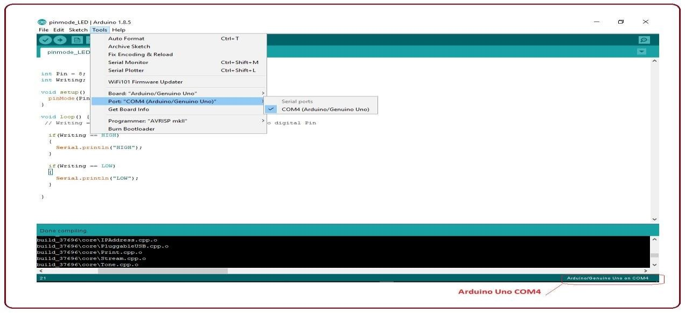

Fig 5.12: Selection of port
Note: The port selection criteria mentioned above are dedicated to Windows operating system only, you can check this Guide if you are using MAC or Linux. The amazing thing about this software is that no prior arrangement or bulk of the mess is required to install this software, you will be writing your first program within 2 minutes after the installation of the IDE environment.

5.1.6 Uploading
After writing your code, click on the upload button which is above the window and the code will be directly uploaded into the Node MCU with a cable wire connector.

CHAPTER-6
RESULT
MEMS-based hand gesture robots represent a significant advancement in human-machine interaction. The high accuracy, low response time, and robustness of MEMS sensors make these systems highly effective in a variety of applications. As the technology continues to evolve, we can expect further improvements in sensor capabilities, data processing algorithms, and overall system integration, leading to even more sophisticated and versatile robotic systems.

Moreover, The responsiveness of the system is another critical factor. MEMS-based hand gesture robots are designed to operate in real-time, with minimal latency between the gesture and the robot's action.

The successful deployment of MEMS-based hand gesture robots highlights the potential for these technologies to revolutionize fields such as healthcare, manufacturing, and personal assistance.

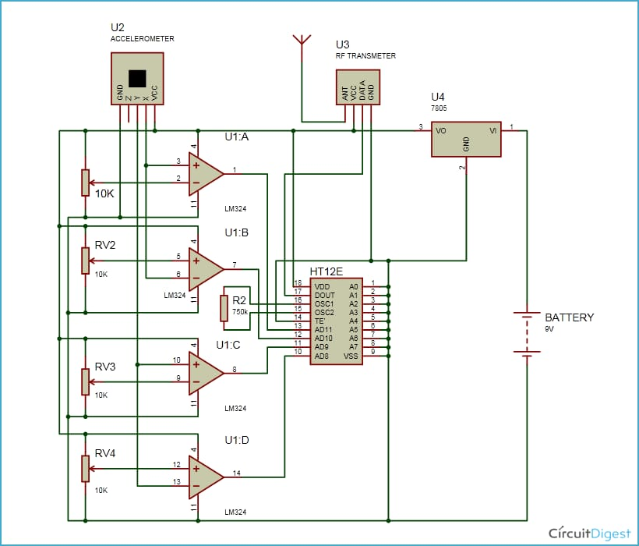
Fig 6.1:Transmitter
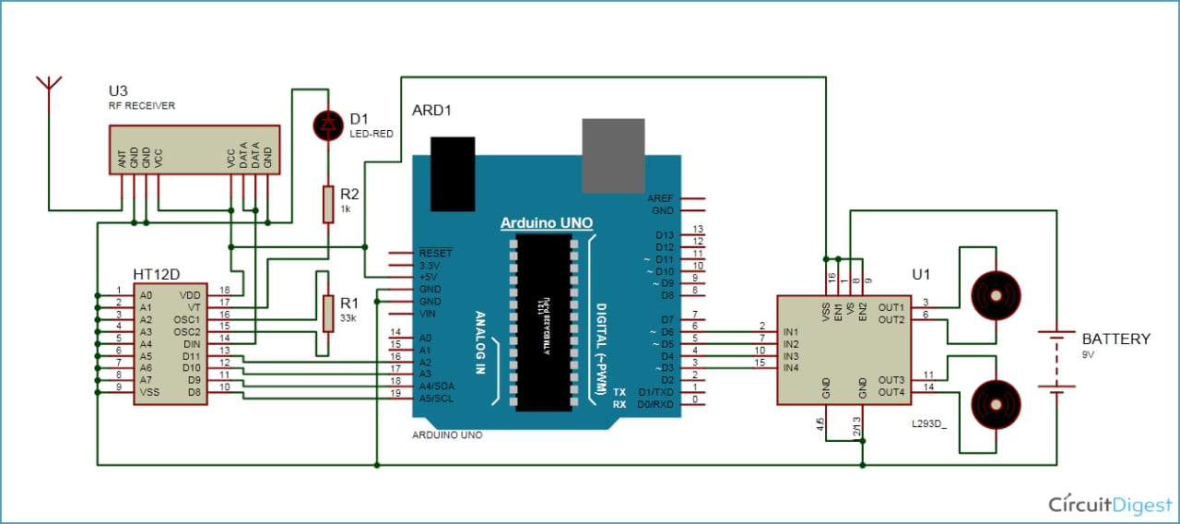
Fig 6.2: Receiver Circuit
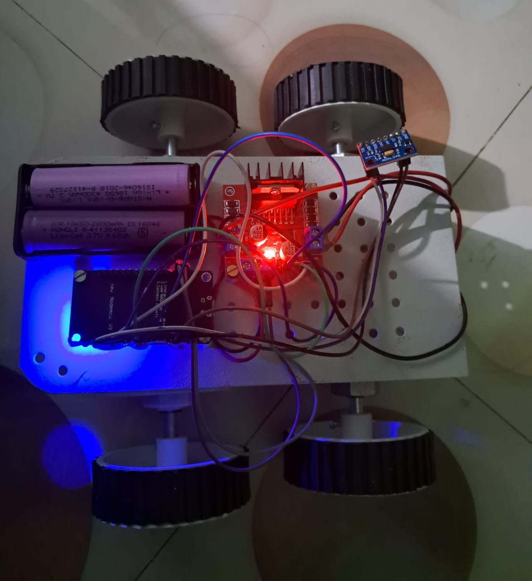

Fig 6.3: Mems Hand Based Gesture Robot

CONCLUSION
MEMS-based hand gesture robots represent a significant advancement in the field of human-machine interaction, providing an intuitive and efficient means of controlling robotic systems through natural hand movements. The utilization of MEMS sensors, such as accelerometers and gyroscopes, enables precise and accurate detection of complex gestures, translating them into actionable commands for the robot.
The key advantages of MEMS-based hand gesture robots include high accuracy in gesture recognition, real-time responsiveness, and robustness against external factors like lighting conditions. These attributes make the technology suitable for a wide range of applications, including industrial automation, medical robotics, and assistive devices for individuals with disabilities.
Moreover, the adaptability of these systems allows for customization to meet specific user needs, enhancing their utility and user experience. As MEMS technology continues to advance, we can expect further improvements in sensor performance and data processing, leading to even more sophisticated and versatile robotic solutions.
In conclusion, MEMS-based hand gesture robots have the potential to revolutionize the way humans interact with machines, offering a seamless and natural interface that enhances productivity and accessibility in various fields. The ongoing development and refinement of this technology promise to unlock new possibilities and applications, making it an exciting area of research and innovation.

FUTURE SCOPE

The future scope of MEMS-based hand gesture robots is expansive and filled with potential, driven by continuous advancements in MEMS technology, artificial intelligence, and robotics. One of the most promising areas of development is the enhancement of sensor precision and miniaturization. As MEMS technology progresses, sensors are expected to become even more accurate and significantly smaller. This miniaturization will lead to more comfortable and unobtrusive wearable devices, improving user experience and broadening the range of applications. Smaller, more precise sensors can be integrated into various wearable forms, from gloves to rings, allowing for more versatile and seamless control of robotic systems.

Integration with advanced AI and machine learning algorithms is another critical area for future development. These technologies will enhance gesture recognition accuracy and adaptability, enabling systems to learn from user behavior and preferences.

Improvements in sensor reliability and system robustness will ensure these robots can operate safely and dependably in critical applications, such as medical surgery and high-risk industrial environments. Enhancements in user interface and experience, including the potential for haptic feedback mechanisms that provide tactile sensations, will also play a crucial role. These advancements will make interactions with hand gesture robots more intuitive and satisfying, paving the way for broader acceptance and integration into everyday life.

SOURCE CODE
#include <Wire.h>
#include <Adafruit_Sensor.h>
#include <Adafruit_ADXL345_U.h>
#define m1 D3
#define m11 D4
#define m2 D5
#define m22 D6

/* Assign a unique ID to this sensor at the same time */
Adafruit_ADXL345_Unified accel = Adafruit_ADXL345_Unified(12345);

void displaySensorDetails(void) {
sensor_t sensor;
accel.getSensor(&sensor);
Serial.println("------------------------------------");
Serial.print("Sensor: "); Serial.println(sensor.name);
Serial.print("Driver Ver: "); Serial.println(sensor.version);
Serial.print("Unique ID: "); Serial.println(sensor.sensor_id);
Serial.print("Max Value: "); Serial.print(sensor.max_value); Serial.println(" m/s^2");
Serial.print("Min Value: "); Serial.print(sensor.min_value); Serial.println(" m/s^2");
Serial.print("Resolution: "); Serial.print(sensor.resolution); Serial.println(" m/s^2");
Serial.println("------------------------------------");
Serial.println("");
delay(500);
}

void displayDataRate(void) {
Serial.print("Data Rate: ");
switch(accel.getDataRate()) {
case ADXL345_DATARATE_3200_HZ: Serial.print("3200 "); break;
case ADXL345_DATARATE_1600_HZ: Serial.print("1600 "); break;
case ADXL345_DATARATE_800_HZ: Serial.print("800 "); break;
case ADXL345_DATARATE_400_HZ: Serial.print("400 "); break;
case ADXL345_DATARATE_200_HZ: Serial.print("200 "); break;
case ADXL345_DATARATE_100_HZ: Serial.print("100 "); break;
case ADXL345_DATARATE_50_HZ: Serial.print("50 "); break;
case ADXL345_DATARATE_25_HZ: Serial.print("25 "); break;
case ADXL345_DATARATE_12_5_HZ: Serial.print("12.5 "); break;
case ADXL345_DATARATE_6_25HZ: Serial.print("6.25 "); break;
case ADXL345_DATARATE_3_13_HZ: Serial.print("3.13 "); break;
case ADXL345_DATARATE_1_56_HZ: Serial.print("1.56 "); break;
case ADXL345_DATARATE_0_78_HZ: Serial.print("0.78 "); break;
case ADXL345_DATARATE_0_39_HZ: Serial.print("0.39 "); break;
case ADXL345_DATARATE_0_20_HZ: Serial.print("0.20 "); break;
case ADXL345_DATARATE_0_10_HZ: Serial.print("0.10 "); break;
default: Serial.print("???? "); break;
}
Serial.println(" Hz");
}

void displayRange(void) {
Serial.print("Range: +/- ");
switch(accel.getRange()) {
case ADXL345_RANGE_16_G: Serial.print("16 "); break;
case ADXL345_RANGE_8_G: Serial.print("8 "); break;
case ADXL345_RANGE_4_G: Serial.print("4 "); break;
case ADXL345_RANGE_2_G: Serial.print("2 "); break;
default: Serial.print("?? "); break;
}
Serial.println(" g");
}

void setup(void) {
Serial.begin(9600);
Serial.println("Accelerometer Test"); Serial.println("");

if(!accel.begin()) {
Serial.println("Ooops, no ADXL345 detected ... Check your wiring!");
while(1);
}

accel.setRange(ADXL345_RANGE_16_G);
displaySensorDetails();
displayDataRate();
displayRange();
Serial.println("");

pinMode(m1, OUTPUT);
pinMode(m11, OUTPUT);
pinMode(m2, OUTPUT);
pinMode(m22, OUTPUT);
stop1();
}

void loop(void) {
sensors_event_t event;
accel.getEvent(&event);
float x = event.acceleration.x;
float y = event.acceleration.y;
float z = event.acceleration.z;

Serial.print("X: "); Serial.print(x); Serial.print(" ");
Serial.print("Y: "); Serial.print(y); Serial.print(" ");
Serial.print("Z: "); Serial.print(z); Serial.print(" "); Serial.println("m/s^2 ");
delay(500);

if(y < -7) {
forward();
} else if(y > 7) {
back();
} else if(x < -7) {
right();
} else if(x > 7) {
left();
} else {
stop1();
}
}

void forward() {
Serial.println("Forward");
digitalWrite(m1, HIGH);
digitalWrite(m11, LOW);
digitalWrite(m2, HIGH);
digitalWrite(m22, LOW);
}

void back() {
Serial.println("Back");
digitalWrite(m1, LOW);
digitalWrite(m11, HIGH);
digitalWrite(m2, LOW);
digitalWrite(m22, HIGH);
}

void left() {
Serial.println("left");
digitalWrite(m1, LOW);
digitalWrite(m11, HIGH);
digitalWrite(m2, HIGH);
digitalWrite(m22, LOW);
}

void right() {
Serial.println("right");
digitalWrite(m1, HIGH);
digitalWrite(m11, LOW);
digitalWrite(m2, LOW);
digitalWrite(m22, HIGH);
}

void stop1() {
Serial.println("Stop");
digitalWrite(m1, LOW);
digitalWrite(m11, LOW);
digitalWrite(m2, LOW);
digitalWrite(m22, LOW);
}

REFERENCES
[1] Chen, K., Wang, Y., & Shi, Y. (2019). "A MEMS-based wearable sensor network for hand gesture recognition." Sensors, 19(23), 5156.
[2] Li, Z., Hu, H., & Lu, T. (2018). "MEMS accelerometer based nonspecific-user hand gesture recognition." IEEE Transactions on Systems, Man, and Cybernetics: Systems, 48(1), 105-111.
[3] Zhang, Z., Wang, S., & Wei, Z. (2020). "Hand gesture recognition using MEMS sensors based on SVM and HMM." Proceedings of the 2020 IEEE International Conference on Robotics and Automation (ICRA), 3758-3763.
[4] Kim, S. K., Lee, J. Y., & Cho, S. J. (2017). "A low-power MEMS-based wearable hand gesture recognition system for human-computer interaction." Sensors, 17(8), 1925. Link
[5] Xia, Z., Zhao, L., & Zhang, L. (2016). "Real-time hand gesture recognition using MEMS motion sensors for human-robot interaction." Journal of Robotics and Autonomous Systems, 82, 75-83.
[6] Sharma, A., Tiwari, M. K., & Singh, S. (2019). "MEMS-based accelerometer and gyroscope sensors for hand gesture recognition using machine learning algorithms." Procedia Computer Science, 165, 444-451.
[7] Choi, J. H., Park, J. Y., & Kang, S. H. (2018). "A real-time hand gesture recognition system using MEMS-based wearable devices." IEEE Sensors Journal, 18(21), 8845-8852.
[8] Lu, T., Wu, H., & Hu, H. (2020). "Gesture recognition using MEMS sensors for industrial robot control." Proceedings of the 2020 International Conference on Industrial Electronics and Applications (ICIEA), 192-198.
[9] Jiang, Y., Liu, H., & Zhang, H. (2017). "Wearable MEMS sensor-based gesture recognition for human-computer interaction." IEEE Transactions on Consumer Electronics, 63(4), 484-490.
[10] Wang, H., Chen, X., & Liu, J. (2016). "Hand gesture recognition using MEMS inertial sensors and support vector machine." Proceedings of the 2016 IEEE International Conference on Automation Science and Engineering (CASE), 551-556.

